Assignment - Tableau
Interactive Dashboard & Tableau Storytelling
Q1. Explain the difference between a Tableau Dashboard and a Tableau Story Point. Give two healthcare-related use cases.
Answer:
Tableau Dashboard
A tableau Dashboard is a collection of multiple visualizations (charts, maps, tables) arranged together for monitoring and analysis. It is also interactive — users can filter, drill down, and explore data.

Tableau Story Point
A Story Point is a sequence of dashboards or sheets arranged to tell a narrative.
It is structured in storytelling — It guides stakeholders’ step by step through insights.

Healthcare Use Case 1:
A hospital dashboard showing patient admissions by department, treatment costs, and outcomes. For example, using your dataset, a dashboard could show average treatment cost by department (Cardiology vs. Orthopaedics vs. Neurology).

Healthcare Use Case 2:
A story that explains regional patient trends → starting with admissions by region, then moving to treatment costs, and finally showing recovery vs. critical outcomes. For example, your dataset shows East region has multiple high-cost treatments (e.g., Neurology Surgery at ₹144,492.77), which could be highlighted in a story.

Q2. What are Actions in Tableau? Explain how Filter Action can help hospital management analyze patient data.

Answer:
Actions in Tableau

Actions are interactive features that allow users to control how data is displayed and connected across different sheets, dashboards, or story points. They make dashboards dynamic by letting users click, hover, or select data to trigger changes elsewhere.
Types include Filter Actions, Highlight Actions, and URL Actions.

Filter Action (with Hospital Dataset)

A Filter Action lets users click on a data point in one visualization and automatically filter related data in another. In hospital management, this is powerful because it connects patient records, costs, outcomes, and departments interactively.
Example using your dataset:

- Suppose you create a dashboard with:

>> A bar chart showing number of patients by Department.
>> A table showing Treatment Cost, Length of Stay, and Outcome for each patient.

- By applying a Filter Action, when hospital management clicks on Neurology, the table instantly filters to show only Neurology patients (e.g., Patient_ID HSP-2003, HSP-2007, HSP-2017, etc.).

- This helps management analyse:

>> Average treatment cost in Neurology (e.g., ₹86,237.31 for HSP-2003, ₹144,492.77 for HSP-2007).
>> Critical vs Recovered outcomes within that department.
>> Length of stay trends (short vs long stays).

Q3 Patient Distribution
Create a Bar Chart showing:
>> Total Patients by Hospital Region.
>> Add this as a Story Point with proper title.
Answer:
1. Load Data
>> Connected Tableau to the Hospital_Management.csv file.
>> Verified that Hospital_Region is a dimension and Patient_ID is a measure.

2. Create Worksheet
>> Dragged Hospital_Region → Columns.
>> Dragged Patient_ID → Rows.
>> Changed aggregation to COUNT(Patient_ID) to show total patients per region.

- Format Chart
>> Changed chart type → Bar Chart.
>> Added labels on bars to display patient counts (Central: 48, East: 49, North: 51, South: 51, West: 61).
>> Applied different colors for each region for clarity.

- Add Title
>> Named the chart: “Q3 Patient Distribution — Total Patients by Hospital Region”.
- Add to Story Point
>> Inserted this worksheet into the Story as a new story point.
Added caption: “West region has the highest patient count, while Central has the lowest.”

Q4 Department Performance
Create a visualization showing:
Treatment Cost by Department.
Add labels and customize colors.

Answer:
1. Open the Q4 worksheet.
2. Drag Department to the Columns shelf.
3. Drag Treatment Cost to the Rows shelf.
4. Ensure the aggregation is SUM(Treatment Cost).
5. From Marks, select Bar chart (if not selected automatically).
6. Drag Department to the Color card to assign different colors to each department.
7. Drag SUM(Treatment Cost) to the Label card or click Show Mark Labels.
8. Customize bar colors from Color → Edit Colors.
9. Format the labels (font size, alignment, number format) as needed.
10. Add the title “Q4 Department Performance” and rename the axis to Treatment Cost.

Q5 Treatment Trend Over Time
Create a Line Chart:
Treatment Cost vs Admission Date.
Filter the data only from March to September.

Answer:

- Drag Admission Date to the Columns shelf.
- Change Admission Date to Month.
- Drag Treatment Cost to the Rows shelf.
- Ensure the measure is SUM(Treatment Cost).
- Change the Marks type to Line.
- Drag Admission Date to the Filters shelf.
- Select only March, April, May, June, July, August, and September in the filter.
- Drag SUM(Treatment Cost) to Label and enable Show Mark Labels.
- Format the chart title as"Q5 Treatment Trend Over Time".

Q6 Outcome Analysis
Create a Pie Chart:
Patient Outcome Distribution (Recovered / Critical / Under Treatment).

Answer:

- Open a new worksheet (Q6 Outcome Analysis).
- Change the Marks type to Pie.
- Drag Outcome to the Color card.
- Drag Patient ID to Angle and change it to CNT(Patient ID).
- Drag CNT(Patient ID) to Label.
- Right-click CNT(Patient ID) → Quick Table Calculation → Percent of Total.
- Enable Show Mark Labels to display percentages.
- Adjust the Size slider to enlarge the pie chart.
- Format the title as"Q6 Outcome Analysis".
Q7 Doctor Performance & Patient KPI Analysis
Task Part A — Doctor Performance
>> Create a Ranked Bar Chart showing:
>> Top Doctors by Total Treatment Cost handled

Task Part B — KPI Creation
Create a KPI visualization showing:
Total Patients Treated

Answer:

Task Part A – Doctor Performance (Ranked Bar Chart)
- Drag Doctor Name to the Rows shelf.
- Drag Treatment Cost to the Columns shelf.
- Ensure the measure is SUM(Treatment Cost).
- Sort the chart in Descending Order by SUM(Treatment Cost).
- Keep the Bar chart type.
- Drag Doctor Name to the Color card to assign different colors.
- Drag SUM(Treatment Cost) to Label and enable labels.
- Apply Rank (Quick Table Calculation → Rank) to display doctor ranking.
- Add the title"Doctor Performance & Patient KPI Analysis".

Task Part B – KPI Creation (Total Patients Treated)
1. Open a new worksheet.
2. Drag Patient ID to the view.
3. Change the aggregation to COUNT(Patient ID).
4. Change the Marks type to Text.
5. Drag CNT(Patient ID) to the Text/Label card.
6. Increase the font size and format the KPI.
7. Add the title"Total Patients Treated".

Q8 Interactive Dashboard
>> Build a Dashboard containing:
1. Region Chart
2. Department Cost Chart
3. Outcome Chart
>> Add Filters:
1. Hospital Region
2. Department
Answer:

Step 1: Create Region Chart
>> Drag Hospital Region to Columns.
>> Drag Patient ID to Rows and use COUNT(Patient ID).
>> Create a Bar Chart and show labels.
Step 2: Create Department Cost Chart
>> Drag Department to Columns.
>> Drag Treatment Cost to Rows and use SUM(Treatment Cost).
>> Add colors and data labels.

Step 3: Create Outcome Chart
>> Change Marks to Pie.
>> Drag Outcome to Color.
>> Drag Patient ID to Angle and use COUNT(Patient ID).
>> Apply Percent of Total and show labels.
Step 4: Build Dashboard
>> Create a new Dashboard.
>> Drag the three worksheets (Region, Department Cost, Outcome) onto the dashboard.
>> Add Hospital Region and Department as filters.
>> Apply filters to All Using This Data Source.
>> Add a Filter Action so selecting an Outcome updates the other charts.

Q9 Storytelling Flow
Create a Tableau Story with minimum 4 Story Points:
>> Patient Distribution
>> Department Cost Analysis
>> Outcome Analysis
>> Doctor Performance

Answer:
1. Click New Story in Tableau.
2. Add a title: "Hospital Management Storytelling Flow".
3. Drag the Patient Distribution worksheet to create the 1st Story Point.
4. Click Duplicate (or New Blank) and add the Department Cost Analysis worksheet as the 2nd Story Point.
5. Add the Outcome Analysis worksheet as the 3rd Story Point.
6. Add the Doctor Performance worksheet as the 4th Story Point.
7. Rename each story point tab appropriately:
>> Patient Distribution
>> Department Cost Analysis
>> Outcome Analysis
>> Doctor Performance
8. Add brief captions/insights for each story point.
9. Use navigation arrows to present the analysis flow from one story point to the next.
Q10 Based on your visuals, answer:
1. Which department generates the highest treatment cost?
2. Which region has more critical patients?
3. What business decisions can hospital management take from these insights?
Answer:
Question 1: Which department generates the highest treatment cost?
1. Open the Department Cost Analysis worksheet.
2. Drag Department to Columns.
3. Drag Treatment Cost to Rows and use SUM (Treatment Cost).
4. Sort the bars in descending order.
5. Add labels to display total treatment cost.
6. Observe the highest bar:
7. Neurology = ₹5,320,473.65 (Highest)
Question 2: Which region has more critical patients?
- Open the Patient Distribution by Region chart.
- Drag Hospital Region to Columns.
- Drag Patient ID to Rows and use COUNT (Patient ID).
- Drag Outcome to Filters.
- Select Critical only.
- Add labels and sort descending.
- Observe the results:
- West = 20 Critical Patients
- South = 20 Critical Patients

Question 3: What business decisions can hospital management take?
- Allocate more resources and specialists to the Neurology department because it handles the highest treatment cost.
- Investigate why West and South regions have the highest number of critical cases.
- Strengthen preventive care and early diagnosis programs in high-risk regions.
- Optimize staffing and equipment allocation based on department workload.
- Monitor treatment outcomes regularly to reduce critical cases and improve recovery rates.

Screenshot of Final Story Points
1.

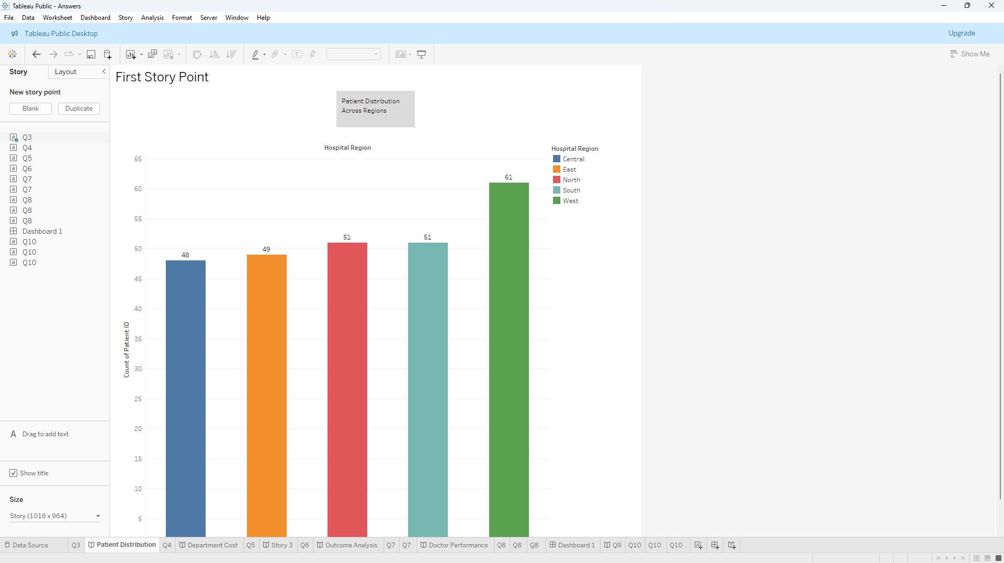
2.
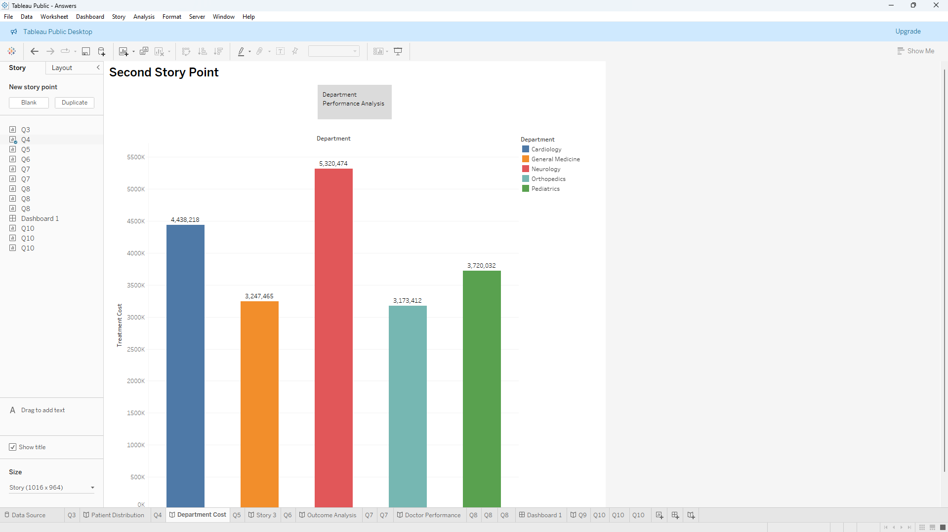
3.
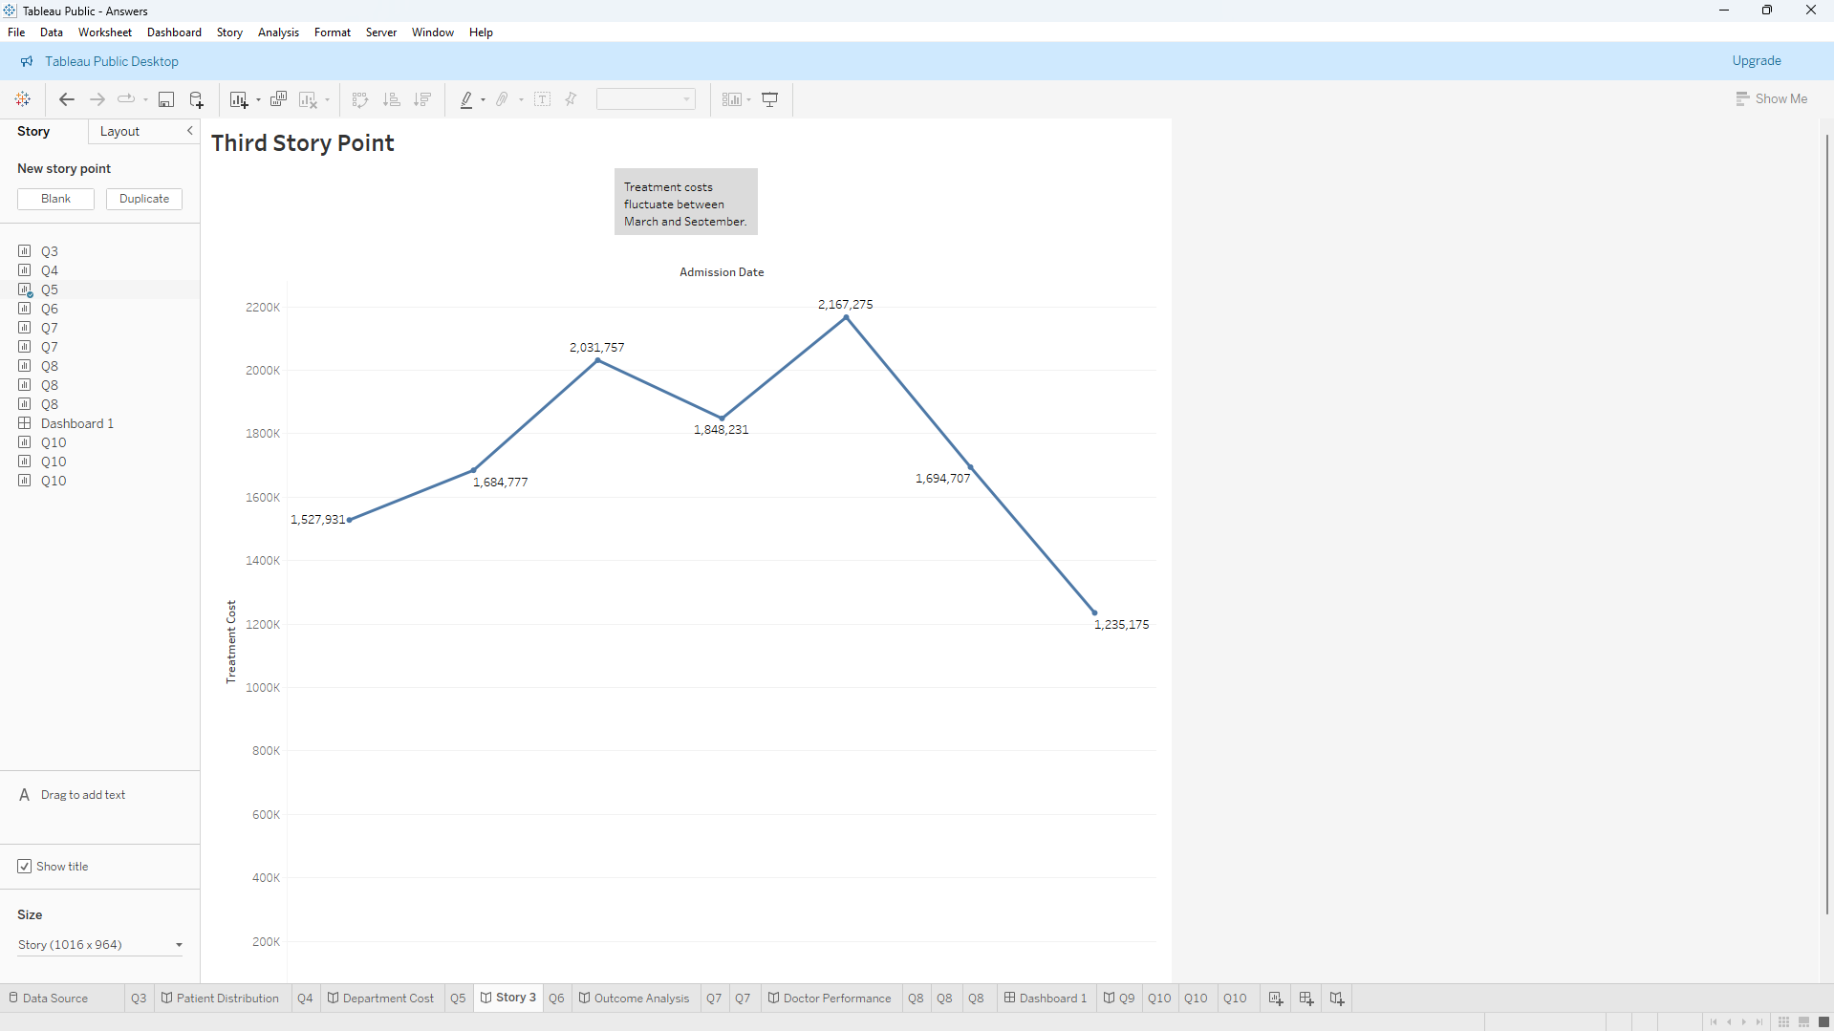
4.
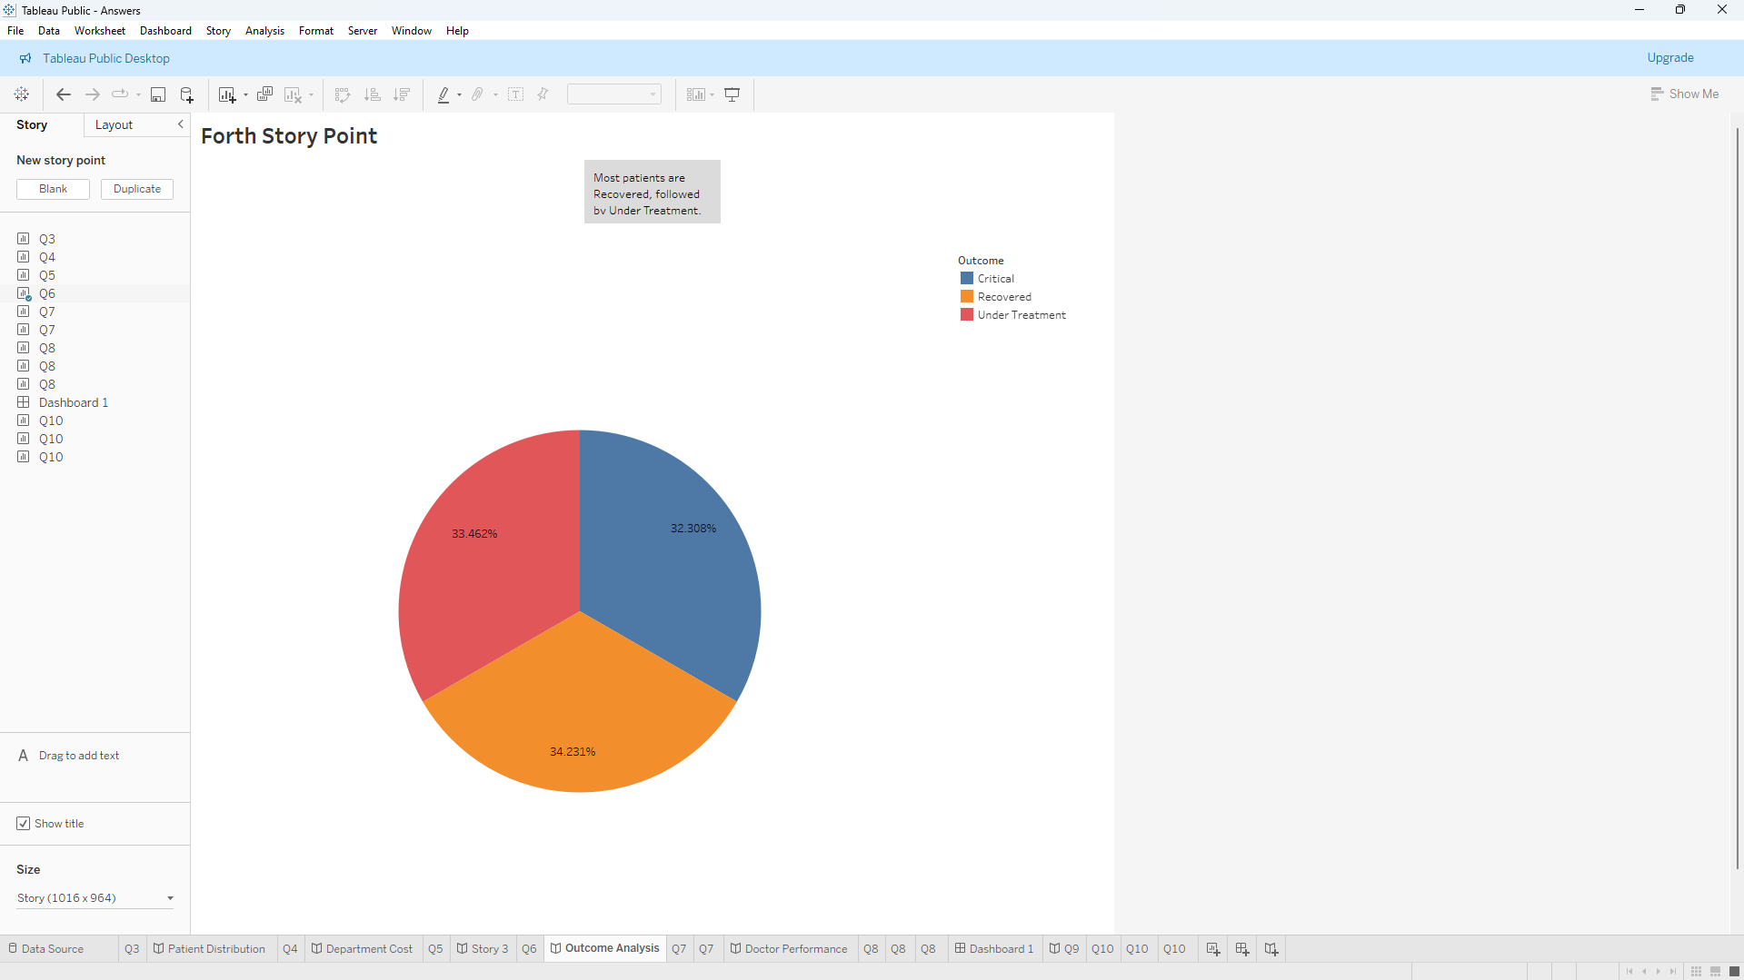
5.
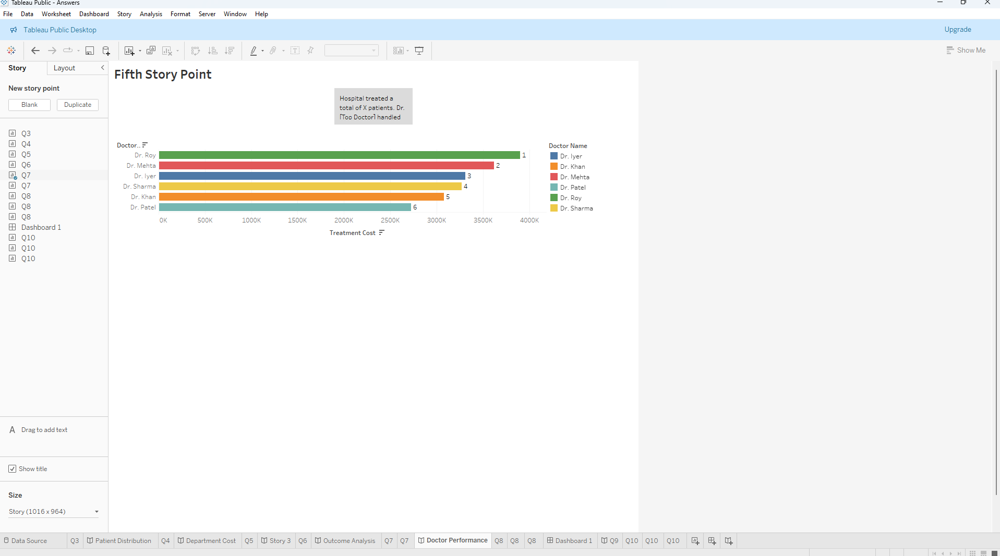
Short Explanation of Insights Derived from Each Visualization
Q3 Patient Distribution
- West region recorded the highest patient count (61 patients).
- Central region recorded the lowest patient count (48 patients).
- Patient volume is relatively balanced across regions.

Q4 Department Cost Analysis
- Neurology generated the highest treatment cost (₹5.32M).
- Cardiology generated the second-highest treatment cost.
- Orthopedics generated the lowest treatment cost.

Q5 Treatment Trend Over Time
- Treatment costs increased from March to July.
- July recorded the highest treatment cost.
- Costs declined from August to September.

Q6 Outcome Analysis
- Recovery, Critical, and Under Treatment outcomes are nearly evenly distributed.
- Recovered patients represent the largest share.
- No single outcome category dominates the dataset.

Q7 Doctor Performance
- Dr. Roy handled the highest total treatment cost.
- Dr. Mehta ranked second in treatment cost handled.
- Dr. Patel handled the lowest treatment cost among the doctors analyzed.

Q7 KPI Analysis
- Total Patients Treated = 260.
- The hospital handled a significant patient volume during the period.

Q8 Interactive Dashboard
- Users can analyze data dynamically using Region and Department filters.
- Dashboard enables comparison of departments, regions, and patient outcomes in one view.

Q9 Storytelling Flow
- The story provides a structured overview from patient distribution to doctor performance.
- Users can easily identify trends and business insights through sequential analysis.

Q10 Business Insights
- Neurology is the highest revenue-generating department.
- West and South regions have the highest number of critical patients.
- Management should allocate additional resources to Neurology and improve critical care services in high-risk regions.

